### Generalized Anxiety Disorder

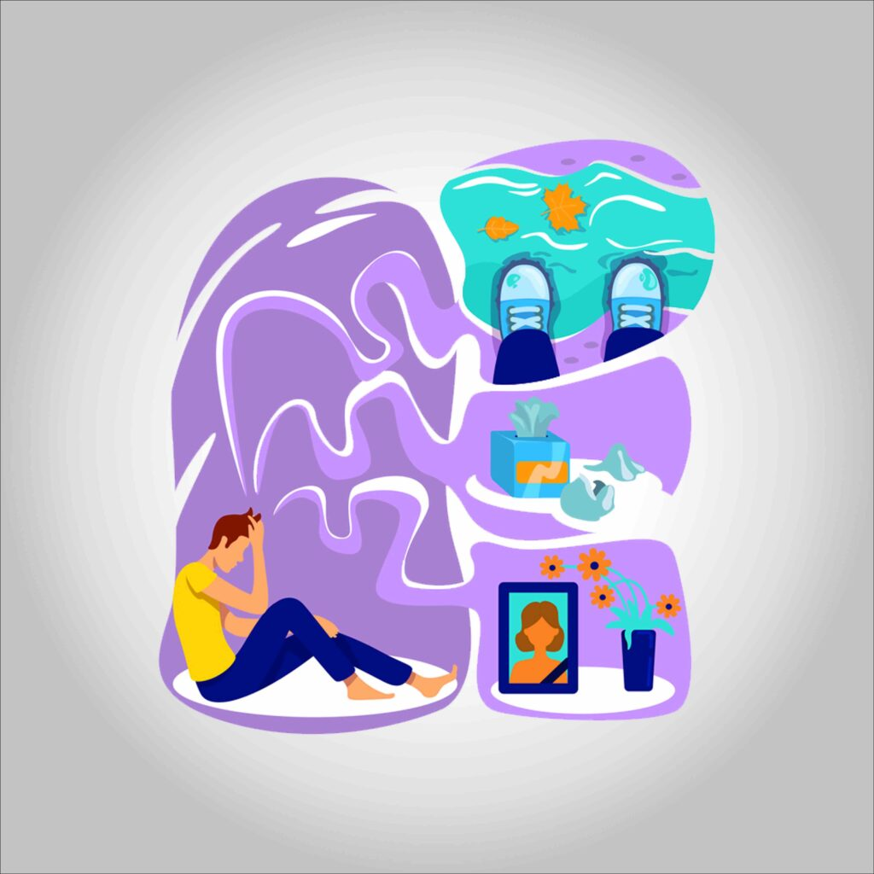

#### ****What is generalized anxiety disorder?****

**People who have generalized anxiety disorder, or GAD, worry uncontrollably about common occurrences and situations. It’s also sometimes known as chronic anxiety neurosis.**

**GAD is different from normal feelings of anxiousness. It’s common to feel anxious about the things happening in your life — such as your finances — every once in a while. A person who has GAD may worry uncontrollably about their finances several times per day for months on end. This can happen even when there isn’t a reason to worry. The person is often aware that there is no reason for them to worry.**

**Sometimes people with this condition just worry, but they are unable to say what they are worried about. They report feelings that something bad may happen or may report that they just can’t calm themselves.**

**This excessive, unrealistic worry can be frightening and can interfere with relationships and daily activities.**

**Symptoms of generalized anxiety disorder**

**This is What it Feels Like to Live with Anxiety**

**Symptoms of GAD include:**

* **difficulty concentrating**
* **difficulty sleeping**
* **irritability**
* **fatigue and exhaustion**
* **muscle tension**
* **repeated stomachaches or diarrhea**
* **sweaty palms**
* **shaking**
* **rapid heartbeat**
* **neurological symptoms, such as numbness or tingling in different parts of the body**

**Distinguishing GAD from other mental health issues**

**Anxiety is a common symptom of many mental health conditions, like depression and various phobias. GAD is different from these conditions in several ways.**

**People with depression may occasionally feel anxious, and people who have a phobia worry about one particular thing. But people with GAD worry about a number of different topics over a long period of time (six months or more), or they may not be able to identify the source of their worry.**

**What are the causes and risk factors for GAD?**

**Causes of and risk factors for GAD may include:**

* **a family history of anxiety**
* **recent or prolonged exposure to stressful situations, including personal or family illnesses**
* **excessive use of caffeine or tobacco, which can make existing anxiety worse**
* **childhood abuse**

**According to the Mayo Clinic, women are twice as likely as men to experience GAD.**

**How is generalized anxiety disorder diagnosed?**

**GAD is diagnosed with a mental health screening that your primary care provider can perform. They will ask you questions about your symptoms and how long you’ve had them. They can refer you to a mental health specialist, such as a psychologist or psychiatrist.**

**Your doctor may also do medical tests to determine whether there is an underlying illness or substance abuse problem causing your symptoms. Anxiety has been linked to:**

* **gastroesophageal reflux disease (GERD)**
* **thyroid disorders**
* **heart disease**
* **menopause**

**If your primary care provider suspects that a medical condition or substance abuse problem is causing anxiety, they may perform more tests. These may include:**

* **blood tests, to check hormone levels that may indicate a thyroid disorder**
* **urine tests, to check for substance abuse**
* **gastric reflux tests, such as an X-ray of your digestive system or an endoscopy procedure to look at your esophagus, to check for GERD**
* **X-rays and stress tests, to check for heart conditions**

#### 

#### ****How is generalized anxiety disorder treated?****

**Cognitive behavioral therapy**

**This treatment involves meeting regularly to talk with a mental health professional. The goal is to change your thinking and behaviors. This approach has been successful in creating permanent change in many people with anxiety. It’s considered first-line treatment for anxiety disorders in people who are pregnant. Others have found that the benefits of cognitive behavioral therapy have provided long-term anxiety relief.**

**In therapy sessions, you will learn how to recognize and control your anxious thoughts. Your therapist will also teach you how to calm yourself when upsetting thoughts arise.**

**Doctors often prescribe medications along with therapy to treat GAD.**

**Medication**

**If your doctor recommends drugs, they will most likely create a short-term medication plan and a long-term medication plan.**

**Short-term medications relax some of the physical symptoms of anxiety, such as muscle tension and stomach cramping. These are called anti-anxiety medications.**

**Anti-anxiety drugs aren’t meant to be taken for long periods of time, as they have a high risk of dependence and abuse.**

**Medications called antidepressants work well for long-term treatment.**

**These medications can take a few weeks to start working. They can also have side effects, such as dry mouth, nausea, and diarrhea. These symptoms bother some people so much that they stop taking these medications.**

**There is also a very low risk of increased suicidal thoughts in young adults at the beginning of treatment with antidepressants. Stay in close contact with your prescriber if you’re taking antidepressants. Make sure you report any mood or thought changes that worry you.**

**Your doctor may prescribe both an anti-anxiety medication and an antidepressant. If so, you’ll probably only take the anti-anxiety medication for a few weeks until your antidepressant starts working, or on an as-needed basis.**

**Lifestyle changes to help ease symptoms of GAD**

**Many people can find relief by adopting certain lifestyle habits. These may include:**

* **regular exercise, a healthy diet, and plenty of sleep**
* **yoga and meditation**
* **avoiding stimulants, such as coffee and some over-the-counter medications, such as diet pills and caffeine pills**
* **talking with a trusted friend, spouse, or family member about fears and worries**

**Outlook for those with generalized anxiety disorder**

**Most people can manage GAD with a combination of therapy, medication, and lifestyle changes. Talk to your doctor if you’re concerned about how much you worry. They can refer you to a mental health specialist.**